# JAVASCRIPT MAPPING

**VARIABLES:**



**DATA-TYPES:**

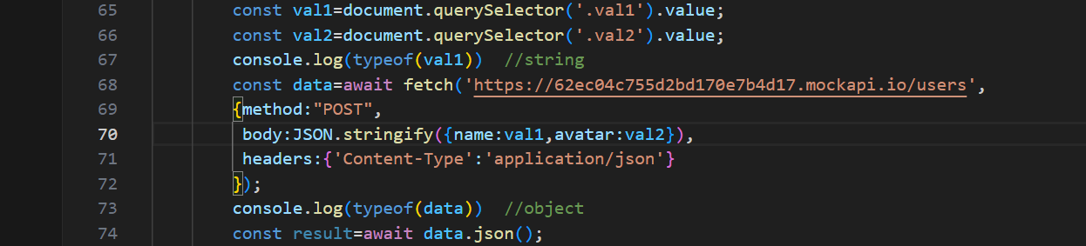

**OPERATORS:**

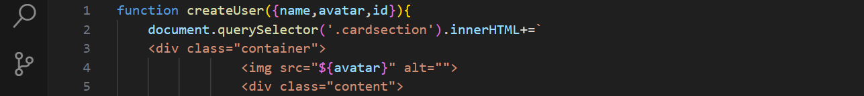

**CONTROL STRUCTURES:**

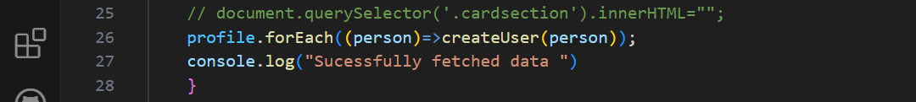

**DOM MANIPULATION:**



**ARRAYS & OBJECTS:**

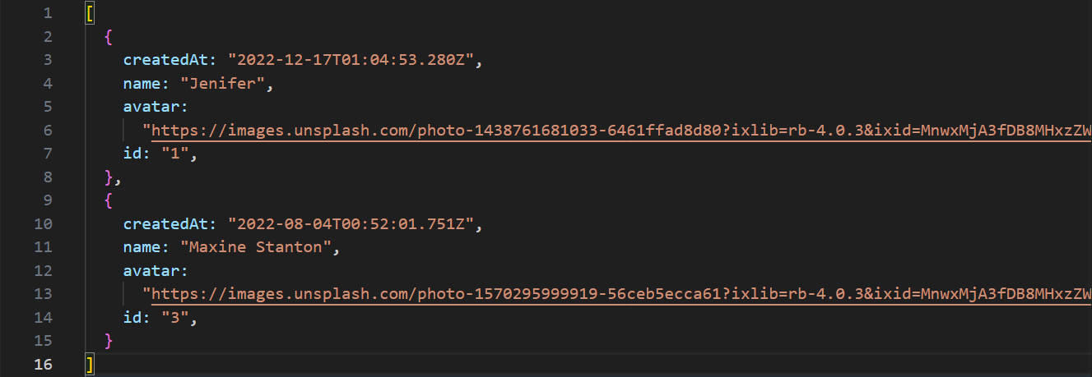

**FUNCTIONS:**

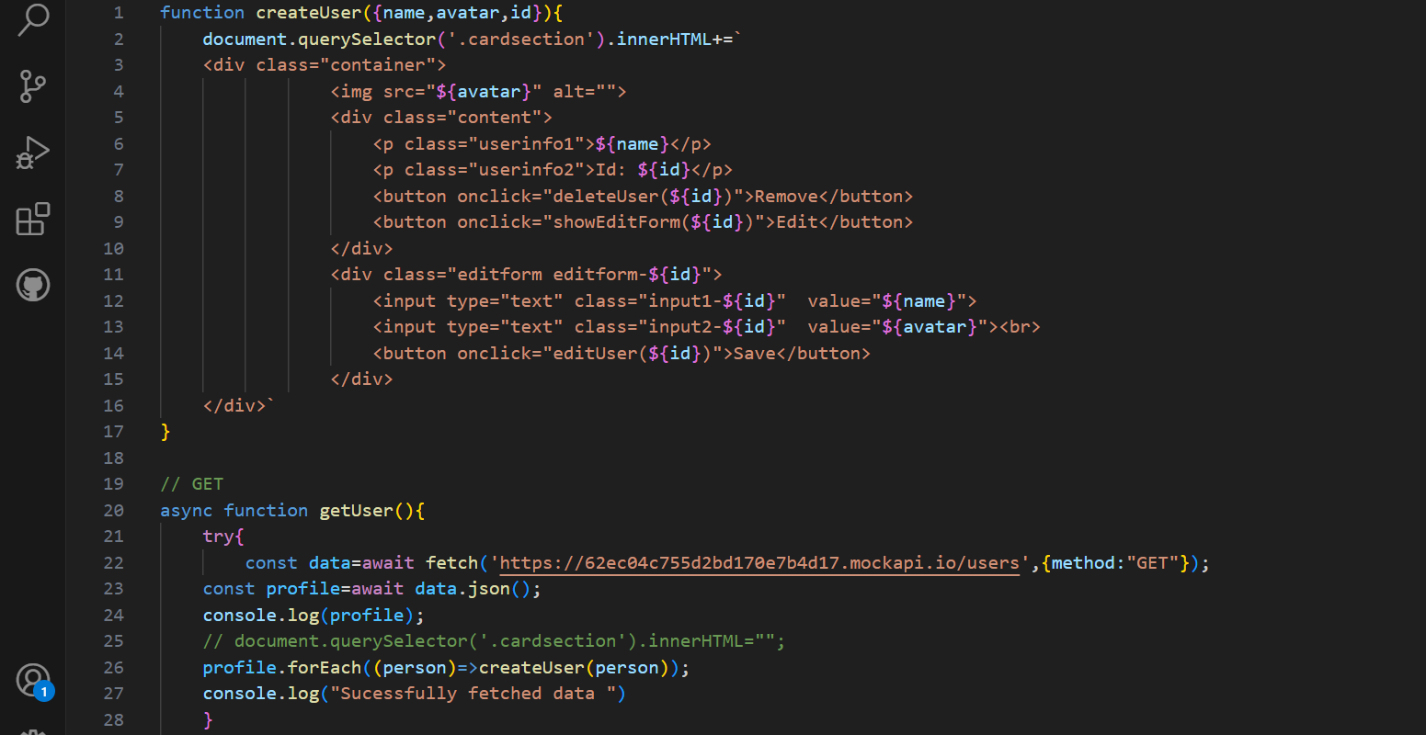

**ASYNCHRONOUS PROGRAMMING: (PROMISES & ASYNC/AWAIT)**

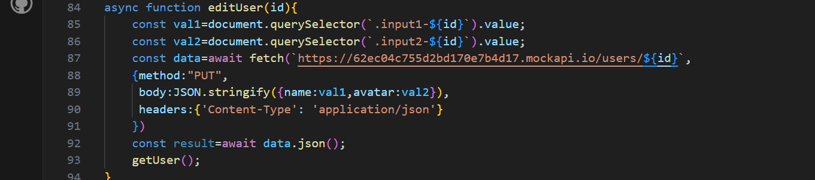

**ERROR HANDLING:**

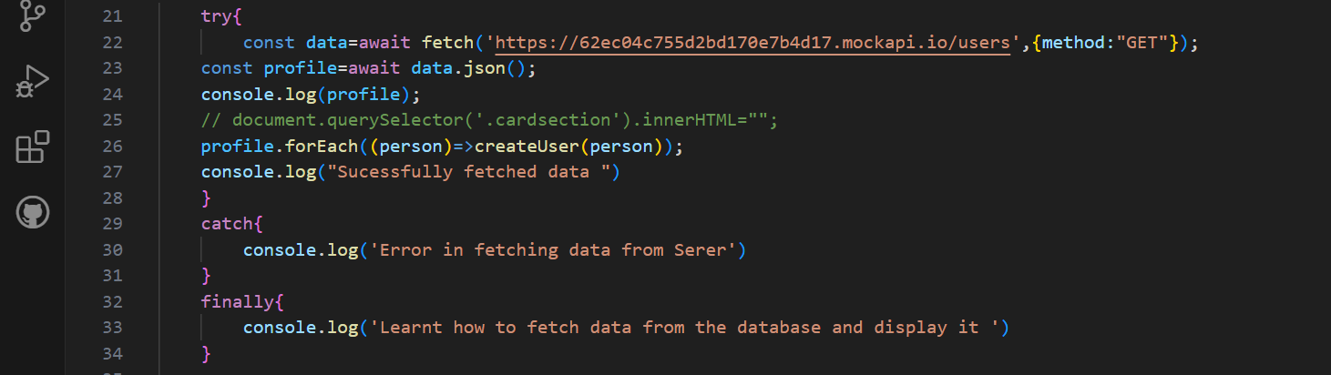

**BROWSER API:**

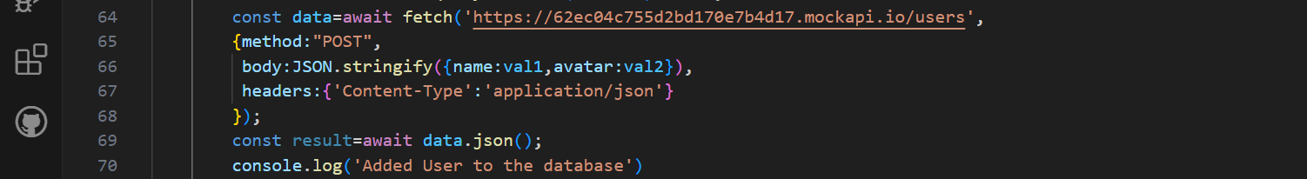

**EVENTS & EVENT HANDLING:**

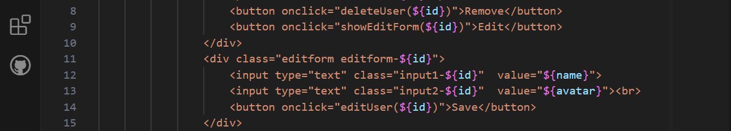

**ES6+ FEATURES:**

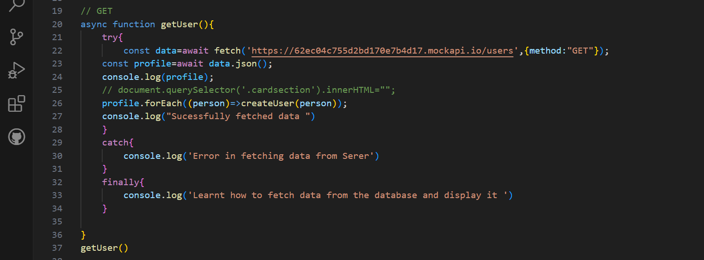

**JSON:**

